Coldstream Christian Camp
4730 Goodman Rd.
Adams, TN 37010
(615) 696-2208

Youth Camp Internship 2019

WHO WE ARE
History 2
Our Mission 2
Statement of Faith 3

REQUIREMENTS
Outline of Internship 4
Supervisory Structure 4
Benefits 5
Requirements 5
INFORMATION & APPLICATION
Biographical Data 6
Experience 6
Personal Testimony 7
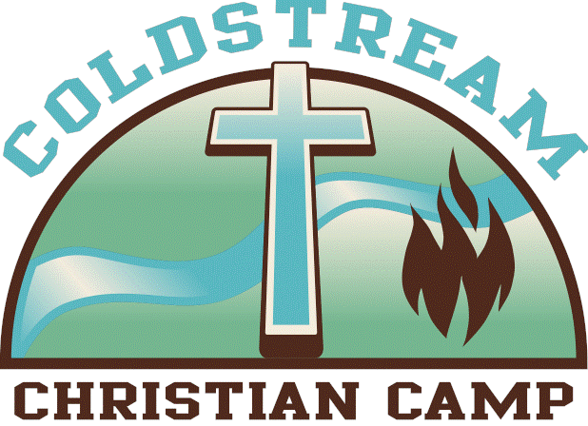

WHO WE ARE

History
Coldstream Christian Camp had its beginning in the heart of a young Robertson County, Tennessee farmer in the late 1970s. As a young boy growing up on a farm, Joe Goodman and his brother camped in a small clearing near the spring that now feeds the lake of Coldstream Christian Camp. At the time, his mind was far from using the land for the Lord's work. When his family mentioned the prospect of the land being used for a Christian camp, Joe was opposed to the idea- after all, that was farmland.
After spending several years away from the farm, Joe returned in 1967, married, and settled down to raise a family. He soon began to see the possibilities for just such a camp. The Lord impressed upon him that he should set aside a portion of his farm for a camping area. His initial goal was to use the camp as a retreat for pastors and missionaries, but it soon became apparent that God was to broaden the scope of the ministry to include ministry to couples, families, children, churches, and other church-related organizations. The necessary paperwork was filed, the camp incorporated, and tax-exempt status sought. Faith, prayers, and patience were answered by the granting of such status on November 5, 1980.

Mission

The mission of Coldstream Christian Camp and Retreat Center is to provide an atmosphere of Christian fellowship in a campground setting, bringing Christian growth to those who have placed their faith in Jesus Christ, and presenting the lost with the Gospel.
Since 1980, God has used Coldstream Christian Camp, in Adams, Tennessee, to minister to thousands of individuals and families through children's camps, church retreats, banquets, wild game dinner retreats, service groups, and numerous other activities. Coldstream is committed to pursuing its mission of providing a place for spiritual growth and evangelization in an outdoor setting, all to the glory of our risen Savior, Jesus Christ.

Statement of Belief

1. We believe that the Bible is the inspired Word of God, is without error in its original languages, and is the ultimate authority for faith and life.

2. We believe in one God, eternally existing in three persons, the Father, Jesus Christ the Son, and the Holy Spirit.

3. We believe in the deity of Christ, in His virgin birth, in His sinless life, in His miracles, in His vicarious and atoning death through His shed blood, in His bodily resurrection, in His ascension to the right hand of the Father, and in His personal return in power and glory.

4. We believe that the salvation of lost and sinful man requires regeneration by the Holy Spirit.

5. We believe in the resurrection of the saved to eternal life and the lost to damnation.

6. We believe in the spiritual unity of all believers in Christ, His church. We believe that the institution of marriage was created by God as a picture of Christ and the church, and is solely between a man and a woman.

7. We believe in holy living, and dedicating ourselves to the service of Christ.

SIGN & DATE BELOW

Staff Signature________________________________________________

Date:_____________

Staff Printed Name:________________________________________________

Outline of Internship
Goals: to relieve administrative burden on camp directors; to ensure smooth process of staff hiring from hiring to end of camps; to better prepare counseling/stream team staff spiritually and practically for their respective weeks; to ensure clear and continual contact between camp staff and summer staff; to ensure campers have a safe and enjoyable experience during camp; to provide an element of objectivity to the hiring process; to encourage and support summer staff in doing kingdom work
Tasks:
- Coordinate counselor interviews and applications
- Recruit new staff
- Assist in assigning of counselor and stream team members to weeks, cabins, tasks, etc.
- Perform background checks on senior counselors
- Stay in touch with counseling/stream team staff throughout the summer through phone and email, providing relevant updates on curriculum and reminders of upcoming dates,
- Schedule ‘counselor get together’ at least once during the summer
- Assist in planning of counselor training
- Create training curriculum for junior staff during Day Camp to encourage them in their work and equip them for the role of a senior staff member
- Teach evening day camp sessions for junior staff, as needed
- Assist in leading group sessions during training
- Keep track of all counselor documents and contact counselors with missing or late references/background checks/apps
- Assign counselors and stream team to electives based on indicated interests/specialties
- Manage camper data
- Draft running list of allergies and restrictions
- Communicate with parents of summer staff minors through email as needed
- Recruit lifeguards
- Assist in drafting curriculum, devotional questions, etc.
- Order/print cabin booklets, staff manuals, t-shirts, pens, notebooks, lanyards, name tags, and any other materials required for all weeks of camp
- Run morning meetings, as needed
- Conduct post-camp interviews and surveys for staff
- Cultivate a culture of respect, encouragement, and gratitude for summer staff
- Set an example of Christ-like leadership and servanthood to all camp participants
- Clearly and authentically live the Gospel through both word and deed for both campers and staff

Supervisory Structure
The youth camp intern will report primarily to the Volunteer Coordinator and the Director/s of Youth Camps. He/she will also work closely with the Teaching and Curriculum Intern and may be required to prepare work to go before the Board of Directors. The Youth Camp Intern will oversee communication with all college-age and younger staff (counselors, day camp, and Stream Team).

Benefits
The youth camp intern will receive a $1000 stipend paid out over the course of ten weeks and will be reimbursed for all work-related expenses. Each intern will record hours spent working in an online timesheet for college credit purposes (if necessary) and for administrative purposes. Room and board are provided for the four weeks the intern is required to spend on campus. This internship is structured to meet course credit requirements for an accredited institution.

Requirements
Applicants must meet the following requirements to be considered for this internship:
- Excellent interpersonal communicators with an ability to form new relationships quickly
- At least two years of college (rising junior) or two years relevant work experience (church ministry, youth ministry, business, YWAM, etc.).
- The ability to travel to Coldstream for any required meetings and commit to spending a minimum of four weeks on campus during youth camps
- Access to internet, a laptop, and high speed internet
- Familiarity with Scripture and the ability to apply biblical lessons to daily life
- Experience working with children and/or young adults
- Excellent administrative skills
- Flexibility and a good attitude; ability to work under pressure
- A heart for the Gospel and passion for evangelism in all forms
- Driver’s license and car
- Two letters of reference (cannot be from a family member)
- The intern will be expected to work a minimum of 15-20 hours independently for the first five weeks. A minimum of 20 hours, with possible travel, will be expected in week six. The next four weeks will be spent full-time on campus during camps. The final week can be worked independently and entails 10-15 hours of work.

Youth Camp Internship Application
Name: Email:
Address:
Birthdate: Gender: M/F
Phone Number: Secondary Phone:
Name of Church:
Please list all social media platforms you use and user names (if applicable)

Are you currently a college student (Y/N)?
If yes, what is your current classification and field of study?

If not, please list any organizations you have worked with in the past that qualify you for this internship, as well as the name and email of your supervisor in those roles.

Please read/sign the attached Statement of Faith and initial below that you are in agreement
____

- Explain how you are qualified for this internship (attach any samples of work you’ve done you believe might be relevant to the job).

2. Please a) briefly summarize your coming to faith, growth throughout the years, and how it influences your work and b) the greatest lesson God is teaching you currently in your walk. Be descriptive and detailed.

3. Why do you want to work at Coldstream? What strengths would you bring to our team? What weaknesses?

4. If you have worked in this position previously, what lessons did you learn last year that you can apply to this year’s internships? Where did you succeed? Where did you fail?

Please submit two letters of reference and this application to the address listed on the cover page of this application OR through applications@coldstreamchristiancamp.org. References must not come from a family member.

